

ASSET VERIFICATION AND RECORDING TOOL KIT


Plot 31, Bukoto Street
P.O Box 7657, Kampala, Uganda
+256 (0) 39 2000216/0772525235
email: cpa@cpa.ug

www.cpa.com

August to September 2026

VERIFICATION DETAILS

NAME OF THE REGION: | NOTHERN REGION
SUB-REGION: | LANGO-SUB REGION
Name of Local Government | DOKOLO DISTRICT LOCAL GOVERNMENT
VERIFIER PARTICULARS
Full name | AGANYO MERCY
Contact/ email and Telephone | 0786551826
Supervisor/ Sub team leader
Name | MR.DENIS
Contact | 0779622063
Date of submission | 2ND SEPTEMBER 2026

HEALTH CENTRES
INFORMANT INTERVIEW/DISCUSSION GUIDE (INCHARGE OR RESPONSIBLE PERSON)

Name of Health Centre: ANYACOTO HEALTH CENTER III

1a | Does the Facility have a record of all assets provided under UgIFT.  (Obtain a record and verify if it has the costs and numbers supplied | YES
1b | If Not ask how many were supplied and when.

2 | How does this facility Maintain (repair/service/replace) the assets provided under Ugift

In case of any damages or breakdown, Anyacoto Health Center III uses the Primary Health Care fund to service and maintain the equipment in the required state.

3 | Does the facility take regular record about functionality/ or breakdown of the assets provided?

Yes, the facility always takes regular records about the functionality of the assets provided.

4 | How has the UgIFT support helped in service delivery in the area, any issues, challenges and any recommendations for better program implementation.

The UGIFT support has helped to improve the health of locals in the community through the equipment provided like the beds, B.P machine and therefore patients are able to access more services.
IT has helped in the accommodation of staff through the construction of staff twin house

Challenges: Some of the equipment brought are weak and therefore they are can’t last long.
Recommendations: UGIFT should allocate some funds to the repair of the equipment provided.

PROCEED TO VERIFICATION AFTER THIS DISCUSSION

Health Centre checklist

NAME OF LG: DOKOLO DISTRICT LOCAL GOVERNMENT NAME OF HEALTH FACILITY: ANYACOTO HEALTH CENTER III

Equipment/ Item | Department | Asset Number | Item  Description | Life in Months | Tag Number ( engrave no.) | Date Of Purchase | Date Placed In Service | Recoverable cost | Cost | Acc Dep Cost | Net Book Value | Ytd Deprn | Equipment status | Remarks
B.P. Machine, Digital (2) | MCH  OPD |  | Digital | 60 | Not engraved | April 2024 | October 2024 |  |  |  |  |  | Functional | Good condition
B.P. Machine (Aneroid wall mounted) | - | - | - | - | - | - | - | -- | - | - | - | - | - | -
Autoclave 20 Liters.,Duo Operated (2) | MCH |  | Plastic | 60 | Not engraved | April 2024 | October 2024 |  |  |  |  |  | Functional | Good condition
Bowl, Kick (2) | MCH  IPD |  | Metallic | 60 | Not engraved | April 2024 | October 2024 |  |  |  |  |  | Functional | Good condition
Bowl Stand (1) | MCH |  | Metallic | 70 | Not engraved | April 2024 | October 2024 |  |  |  |  |  | Functional | Good condition
Counting chamber Neubauer- Improved (1) | Store |  | Plastic | 60 | Not engraved | April 2024 | - |  |  |  |  |  | Non-functional | Still kept in the store
Cupboard Steel, Lockable | MCH  OPD |  | Metallic | 90 | Not engraved | April 2024 | October 2024 |  |  |  |  |  | Functional | Good condition
Drip Stand (8) | MCH  IPD |  | Metallic | 70 | Not engraved | April 2024 | October 2024 |  |  |  |  |  | Functional | Good condition
ESR Stand(1) | Store |  | Glass in nature | 36 | Not engraved | April 2024 | October 2024 |  |  |  |  |  | Non-functional | condition
Examination Couch (2) | MCH  OPD |  | Metallic bed with mattress | 90 | Not engraved | April 2024 | October 2024 |  |  |  |  |  | Functional | Good condition
Examination light,LED (2) | MCH |  | Plastic | 60 | Not engraved | April 2024 | October 2024 |  |  |  |  |  | Functional | Good condition
Glucometer (1) | LAB |  | Digital | 36 | Not engraved | April 2024 | October 2024 |  |  |  |  |  | Functional | Good condition
Haemoglobin Meter, Digital (2) | Store |  | Digital | 40 | Not engraved | April 2024 | October 2024 |  |  |  |  |  | Non-functional | It got spoilt
Height Meter (1) | OPD  MCH |  | Metallic | 60 | Not engraved | April 2024 | October 2024 |  |  |  |  |  | Functional | Good condition
Instrument Trolley (1) | MCH |  | Metallic | 70 | Not engraved | April 2024 | October 2024 |  |  |  |  |  | Functional | Good condition
Microscope Binocular (1) | Store |  | Metallic | 50 | Not engraved | April 2024 | October 2024 |  |  |  |  |  | Non-functional | It can’t see the parasites clearly
Otoscope (2) | OPD |  | Manual | 60 | Not engraved | April 2024 | October 2024 |  |  |  |  |  | Functional | Good condition
Patient Screen(1) | Store |  | Plastic and rubber | 40 | Not engraved | April 2024 | - |  |  |  |  |  | Non-functional | Still kept in the store
Patient Trolley (2) | MCH  IPD |  | Metallic | 60 | Not engraved | April 2024 | October 2024 |  |  |  |  |  | Functional | Good condition
Refrigerator, Basic (1) | Store |  | Metallic | 60 | Not engraved | April 2024 | October 2024 |  |  |  |  |  | Non-functional | It got spoilt
Stethoscope (4) | MCH  OPD |  | Manual | 60 | Not engraved | April 2024 | October 2024 |  |  |  |  |  | Functional | Good condition.
Stop Watch (2) | Store |  | Metallic | 40 | Not engraved | April 2024 | - |  |  |  |  |  | Non-functional | Still in the store
Stretcher (1) |  |  |  |  | Not engraved
Stove, Gas (1) | MCH |  | Metallic | 70 | Not engraved | April 2024 | October 2024 |  |  |  |  |  | Functional | Good condition.
Weighing Scale with Height Meter, Adult (2) | MCH  OPD |  | Metallic | 60 | Not engraved | April 2024 | October 2024 |  |  |  |  |  | Functional | Good condition.
Weighing Scale, Infant ( 2) | ANC  MCH |  | Plastic | 50 | Not engraved | April 2024 | October 2024 |  |  |  |  |  | Functional | Good condition
Weighing Scale, Toddler (1) | MCH |  | Plastic | 60 | Not engraved | April 2024 | October 2024 |  |  |  |  |  | Functional | Good condition
Wheel Chair(3) | MCH  IPD |  | Metallic with leather | 60 | Not engraved | April 2024 | October 2024 |  |  |  |  |  | Functional | Good condition
Audio Visual Equipment(1) | Store |  | Manual | 50 | Not engraved | April 2024 | October 2024 |  |  |  |  |  | Functional | Good condition
Medical Waste Bin  (12) | MCH  LAB  IPD  OPD |  | Both plastic and metallic | 70 | Not engraved | April 2024 | October 2024 |  |  |  |  |  | Functional | Good condition
Wall Clock(6) | MCH  OPD  ANC |  | Plastic and circular | 36 | Not engraved | April 2024 | October 2024 |  |  |  |  |  | Functional | Good condition
Diagnostic Equipment Set for MCH (2) | MCH |  | Metallic | 60 | Not engraved | April 2024 | October 2024 |  |  |  |  |  | Functional | Good d condition
Diagnostic Equipment Set for OPD (3) | OPD |  | Metallic | 60 | Not engraved | April 2024 | October 2024 |  |  |  |  |  | Functional | Good condition
Glassware Set, Laboratory, Basic (1) | IPD  MCH |  | Metallic | 60 | Not engraved | April 2024 | October 2024 |  |  |  |  |  | Functional | Good condition
Hollow Ware Set, Treatment (2) | MCH |  | Metallic | 50 | Not engraved | April 2024 | October 2024 |  |  |  |  |  | Functional | Good condition
Instrument Set, Dressing (2) | OPD  MCH |  | Stainless steel | 60 | Not engraved | April 2024 | October 2024 |  |  |  |  |  | Functional | Good connotation
Instrument Set, Basic ENT (3) | MCH  IPD |  | Stainless steel | 60 | Not engraved | April 2024 | October 2024 |  |  |  |  |  | Functional | Good condition
Instrument Set, Suture | - | - | - | - | - | - | - | - | - | - | - | - | - | -
- | -
Pulse Oximeter, Hand held (2) | MCH  OPD |  | Manual | 60 | Not engraved | April 2024 | October 2024 |  |  |  |  |  | Functional | Good condition
Bed, Adult Patient with Mattress (10) | MCH  IPD |  | Metallic bed with mattress | 90 | Not engraved | April 2024 | October 2024 |  |  |  |  |  | Functional | Good condition
Bed, Pediatric Patient, With Mattress (2) | IPD |  | Metallic Bed with mattress | 90 | Not engraved | April 2024 | October 2024 |  |  |  |  |  | Functional | Good condition
Bedside Locker (4) | MCH  IPD |  | Metallic | 70 | Not engraved | April 2024 | October 2024 |  |  |  |  |  | Functional | Good condition
Cupboard, Instrument (1) | MCH |  | Metallic | 70 | Not engraved | April 2024 | October 2024 |  |  |  |  |  | Functional | Good condition
Delivery Bed, Hydraulic Manual (1) | MCH |  | Manual | 70 | Not engraved | April 2024 | October 2024 |  |  |  |  |  | Functional | Good coditionMCH
Oxygen Therapy Apparatus, Mininum 45L cylinder (1) | MCH |  | Metallic | 70 | Not engraved | April 2024 | October 2024 |  |  |  |  |  | Functional | Good condition
Resuscitator Manual, Infant, with all Mask sizes (4) | MCH |  | RUBBER | 60 | Not engraved | April 2024 | October 2024 |  |  |  |  |  | Functional | Good condition
Resuscitator Manual, Adult, with all mask sizes (6) | MCH |  | Rubber | 60 | Not engraved | April 2024 | October 2024 |  |  |  |  |  | Functional | Good condition
Suction Apparatus, (Electric) (1) | Store |  | Electrical | 50 | Not engraved | April 2024 | October 2024 |  |  |  |  |  | Functional | Good condition
Nebulizer, Ultrasonic (1) | Store |  | Digital | 50 | Not engraved | April 2024 | October 2024 |  |  |  |  |  | Functional | Good condition
Oxygen Concentrator, Duo Flow (2) | MCH |  | Plastic | 50 | Not engraved | April 2024 | October 2024 |  |  |  |  |  | Functional | Good condition
Bench (4) | MCH  OPD |  | Wooden | 90 | Not engraved | April 2024 | October 2024 |  |  |  |  |  | Functional | Good condition
Disinfection Buckets (6) | MCH  OPD |  | Metallic | 60 | Not engraved | April 2024 | October 2024 |  |  |  |  |  | Functional | Good working condition
Baby Cot (3) | MCH |  | Plastic | 60 | Not engraved | April 2024 | October 2024 |  |  |  |  |  | Functional | Good condition
Diagnostic Equipment Set for Ward (2) | Store |  | Metallic | 60 | Not engraved | April 2024 | October 2024 |  |  |  |  |  | Functional | Good condition
Hollow Ware Set, Ward | - | - | - | - | - | - | - | - | - | - | - | - | - | -
- | -
Instrument Set, Delivery (3) | MCH |  | Metallic | 60 | Not engraved | April 2024 | October 2024 |  |  |  |  |  | Functional | Good condition
Instrument Set, Stitch Removing (2) | MCH  IPD |  | Metallic | 60 | Not engraved | April 2024 | October 2024 |  |  |  |  |  | Functional | Good condition
MVA Kit (3) | MCH |  | Plastic | 60 | Not engraved | April 2024 | October 2024 |  |  |  |  |  | Functional | Good condition
Stool, Laboratory (1) | LAB |  | Metallic with leather | 70 | Not engraved | April 2024 | October 2024 |  |  |  |  |  | Functional | Good d condition
Penguin Sucker (3) | MCH |  | Rubber | 60 | Not engraved | April 2024 | October 2024 |  |  |  |  |  | Functional | Good condition
Fetoscope, Dopplar (2) | MCH |  | Metallic | 70 | Not engraved | April 2024 | October 2024 |  |  |  |  |  | Functional | Good condition
Bubble CPAP | - | - | - | - | - | - | - | - | - | - | - | - | - | -
Centrifuge (Electric) (1) | Store |  | Electrical | 60 | Not engraved | April 2024 | - |  |  |  |  |  | Non-functional | Good condition
Kangaroo Mother Care Chair (1) | MCH |  | Metallic with leather | 60 | Not engraved | April 2024 | October 2024 |  |  |  |  |  | Functional | Good condition
Radiant Infant Warmer | - | - | - | - | - | - | - | - | - | - | - | - | - | -
- | - | - | -
Haemoglobin Meter, Sahli (1) | Store |  | Manual | 60 | Not engraved | April 2024 | October 2024 |  |  |  |  |  | Non-functional | Its outdated
Delivery Bed | -- | - | - | - | - | - | - | - | - | - | - | - | - | -
Examination light (3) | OPD  MCH |  | Plastic | 60 | Not engraved | April 2024 | October 2024 |  |  |  |  |  | Functional | Good condition
Instrument set, ENT Basic for HCIII(2) | Store |  | Metallic | 60 | Not engraved | April 2024 | October |  |  |  |  |  | Functional | Good condition
Bag Valve mask (Ambu Bag), Neonatal (1) | MCH |  | Rubber | 6 | Not engraved | April 2024 | October 2024 |  |  |  |  |  | Functional | Good condition
Incubator | - | - | - | - | - | - | - | - | - | - | - | - | -
Office Chair (5) | MCH  OPD  IPD |  | wooden with metallic stand | 80 | Not engraved | April 2024 | October 2024 |  |  |  |  |  | Functional | Good condition but two are broken
Desk (4) | OPD |  | Wooden | 90 | Not engraved | April 2024 | October 2024 |  |  |  |  |  | Functional | Good condition
Filing Cabinet (2) | MCH |  | Metallic | 70 | Not engraved | April 2024 | October 2022 |  |  |  |  |  | Functional | Good condition
Non Residential Buildings(1) | Health |  | Concrete building | 300 | Not engraved | April 2024 | October 2024 |  |  |  |  |  | Functional | It is in a good state
Pit latrine
Residential Buildings (2)
MCH WARD  Staff house | Health |  | Block concrete building | 600 | Not engraved | April 2024 | October 2024 |  |  |  |  |  | Functional | Good state

SAMPLE PICTURES OF ANYACOTO HEALTH CENTRE III

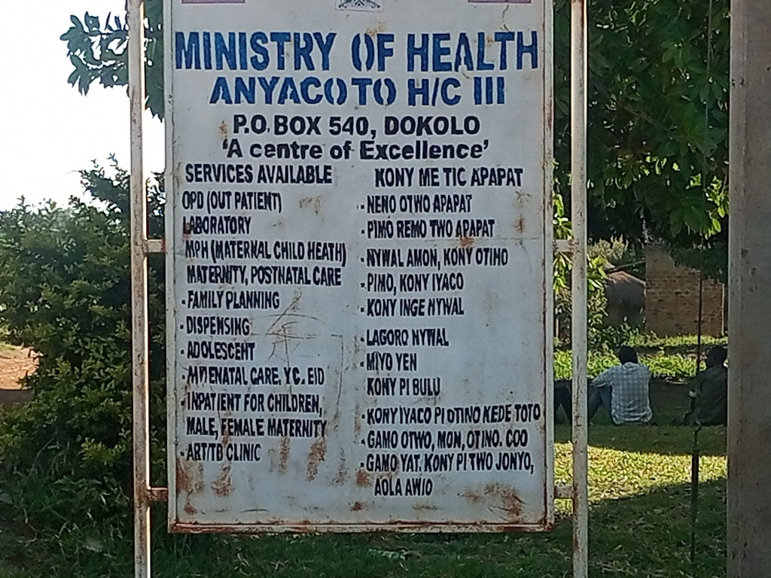

Anyacoto Health Centre III

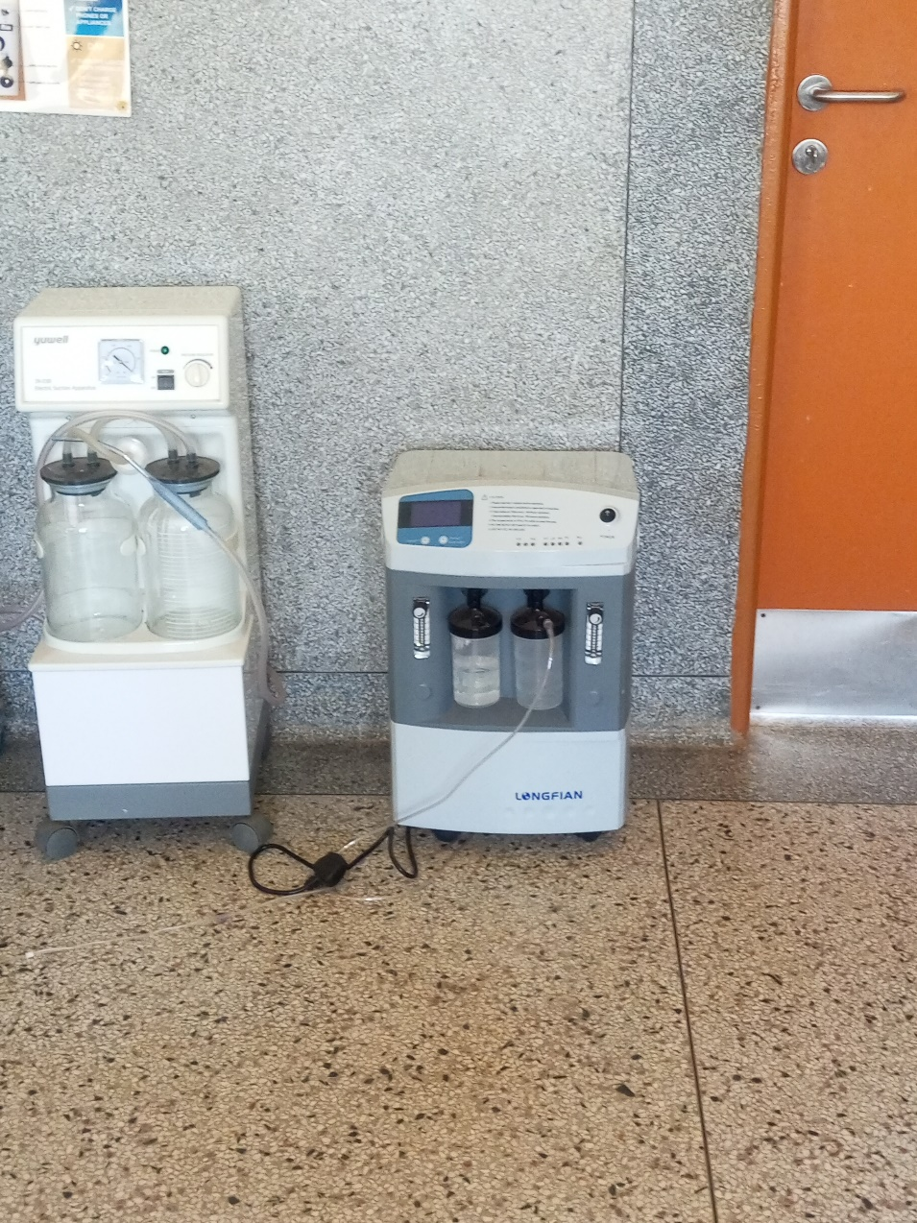

Oxygen Concentration

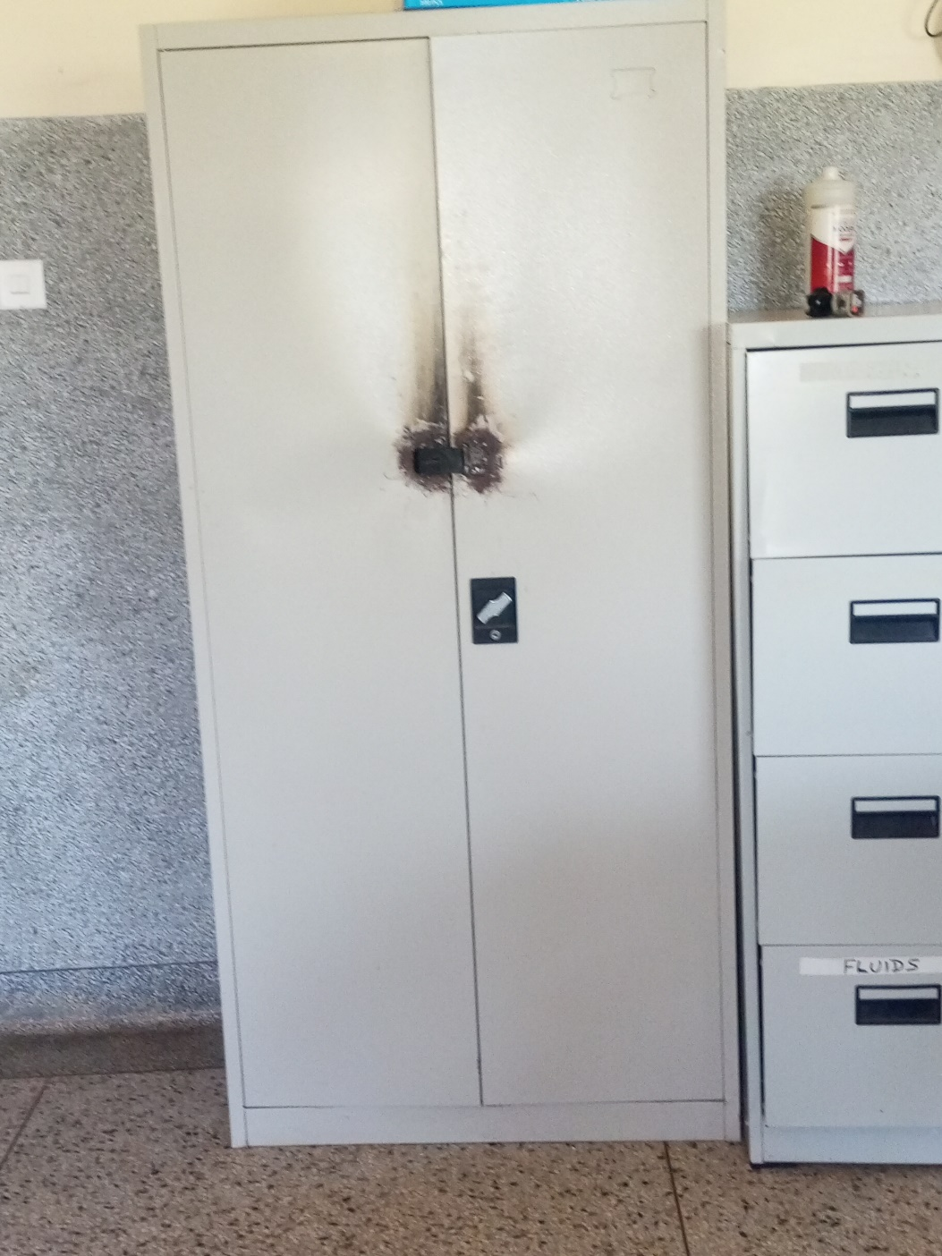

Cupboard Steel Lockable
and
Filing Cabinet

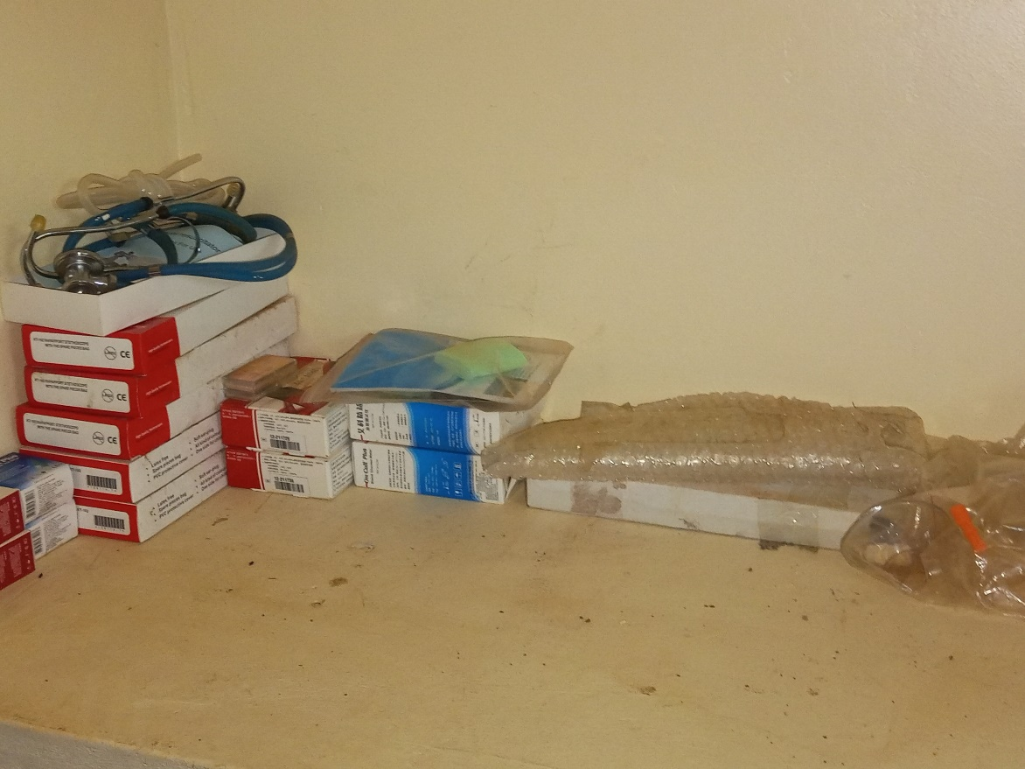

Assets in the Store

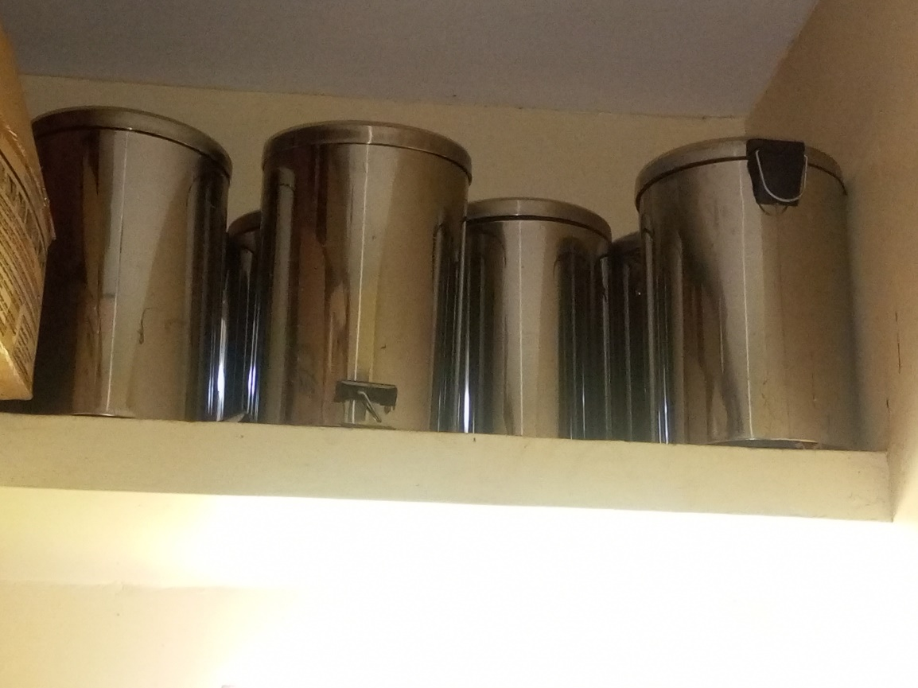

Equipment in
the Store

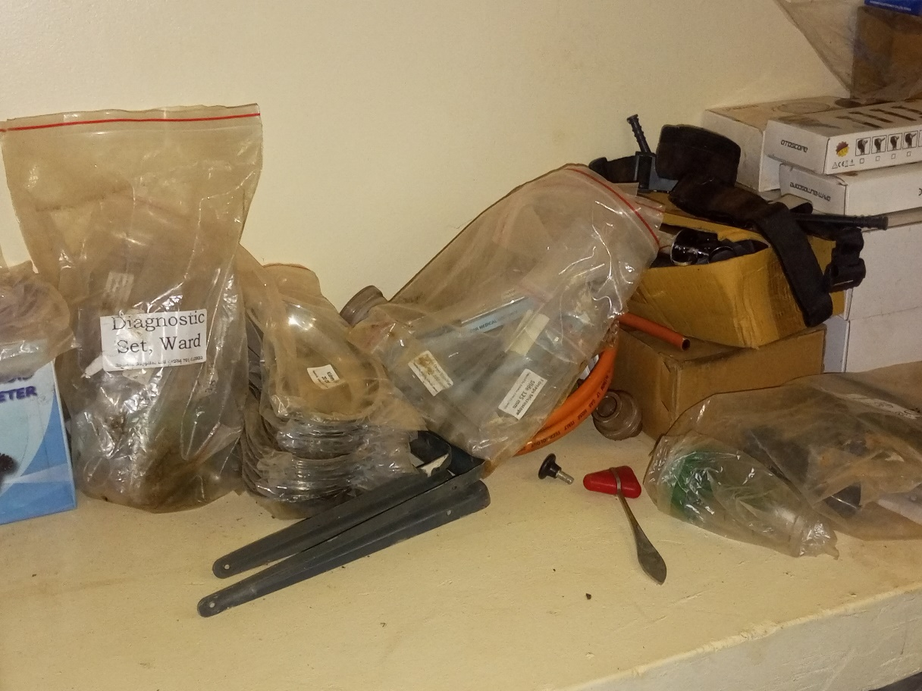

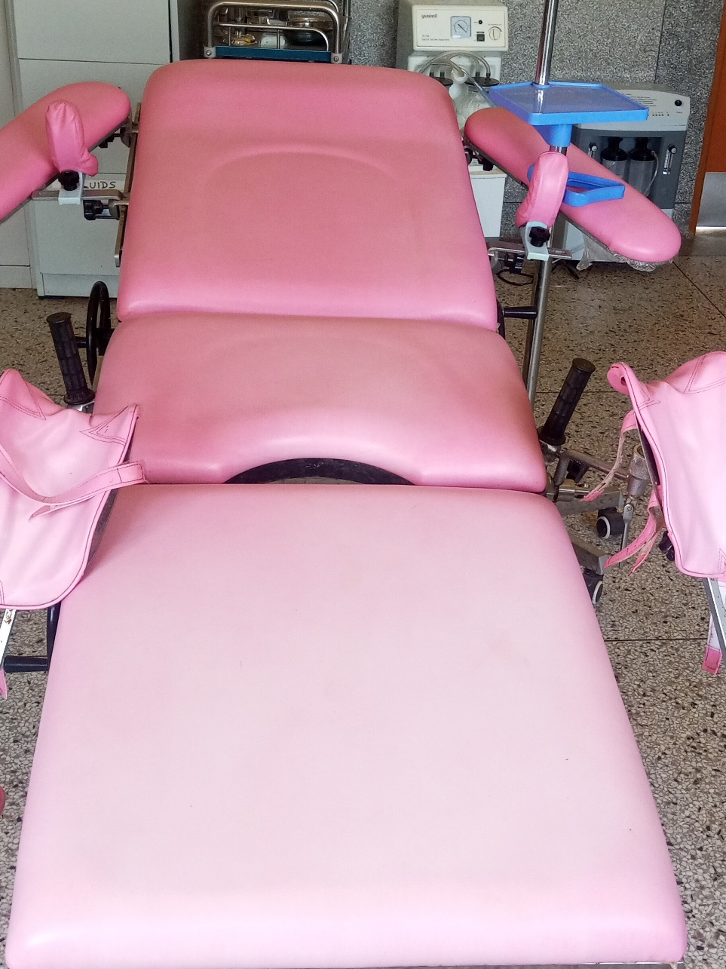

Delivery Bed Hydraulic Manual

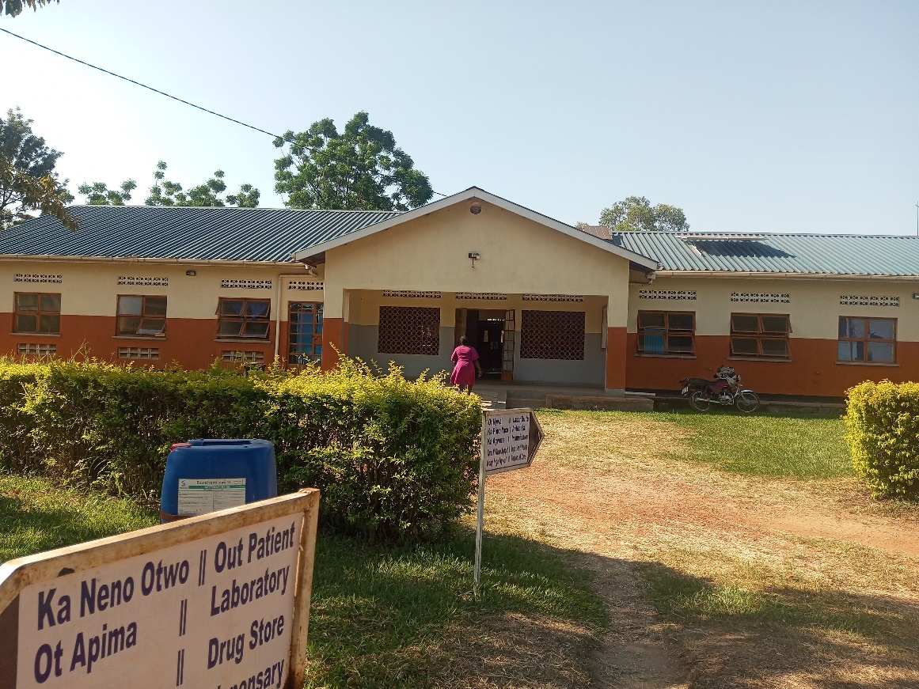

MCH Ward

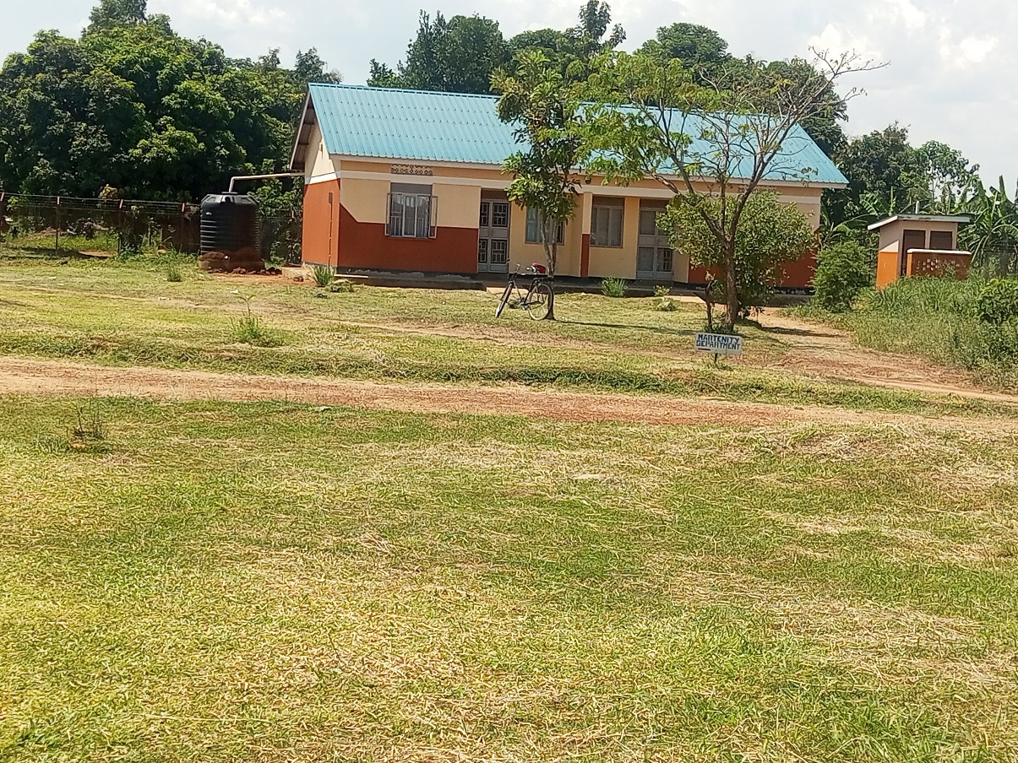

Staff Twin House

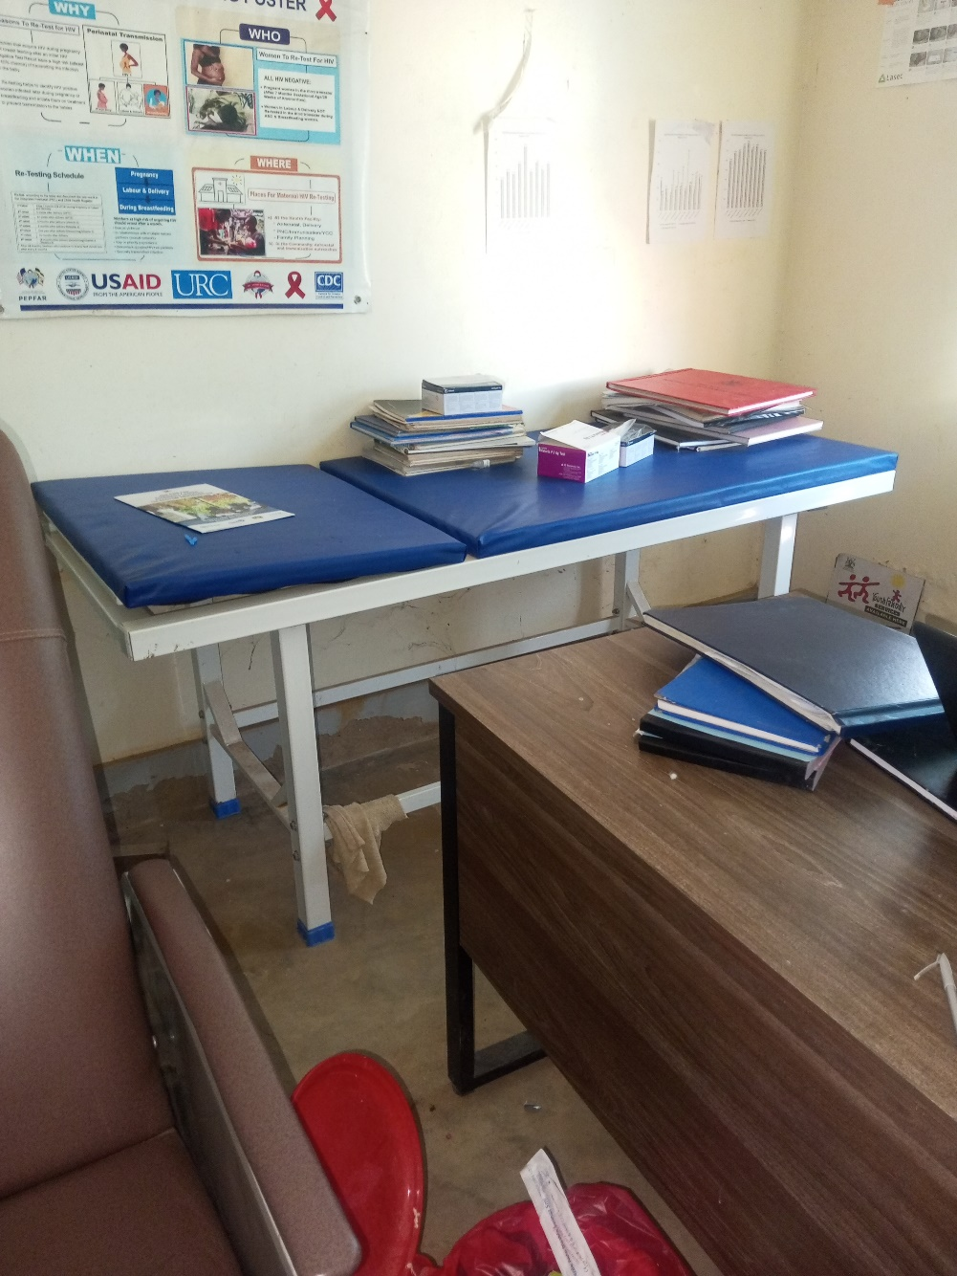

Examination Couch

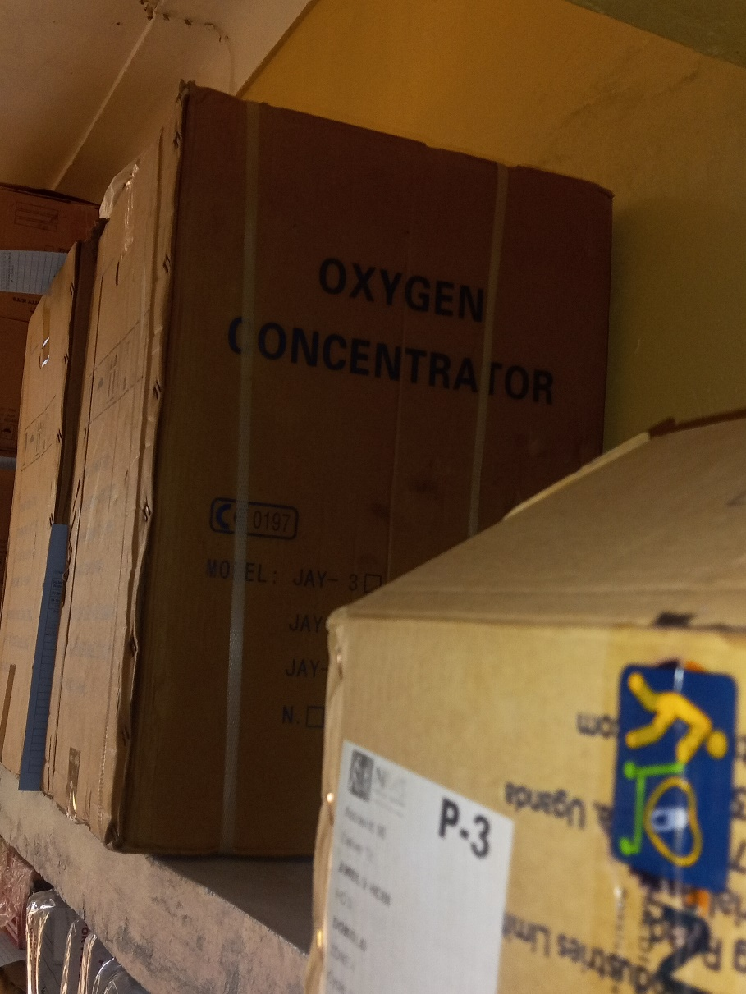

Equipment in Store

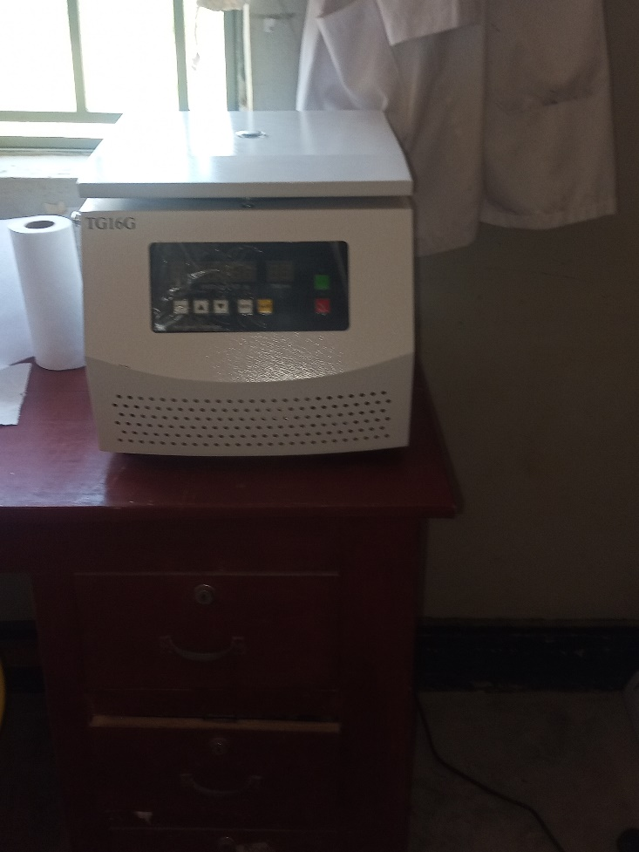

Centrifuge

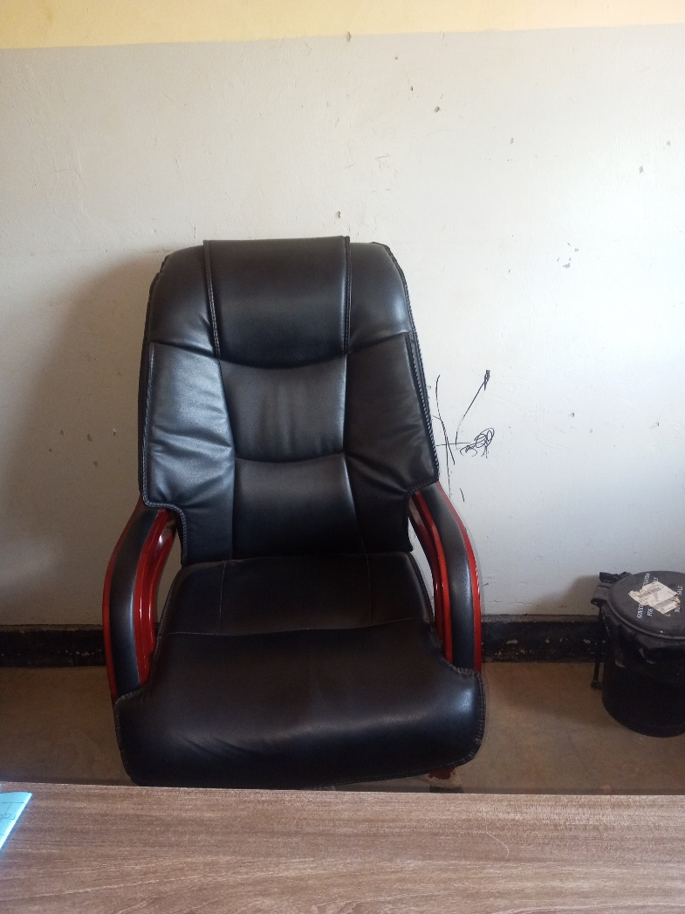

Sample of Office Chair

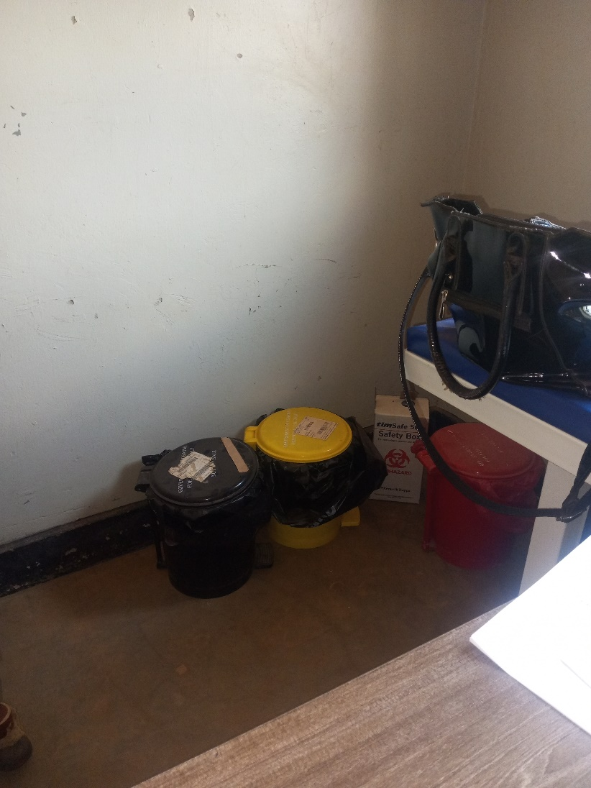

Sample of Medical Waste Bin

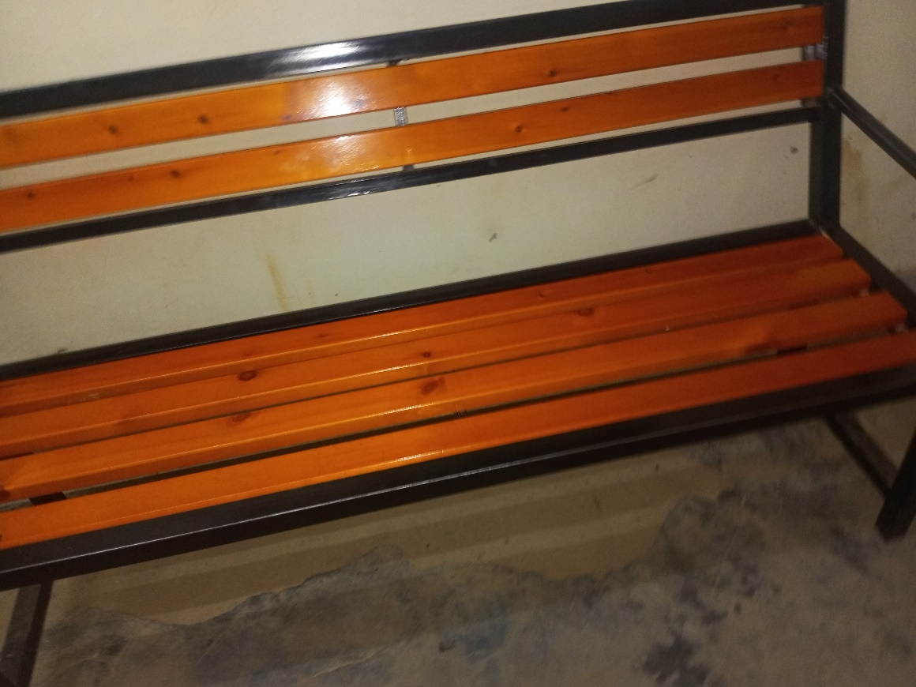

Sample of a Bench

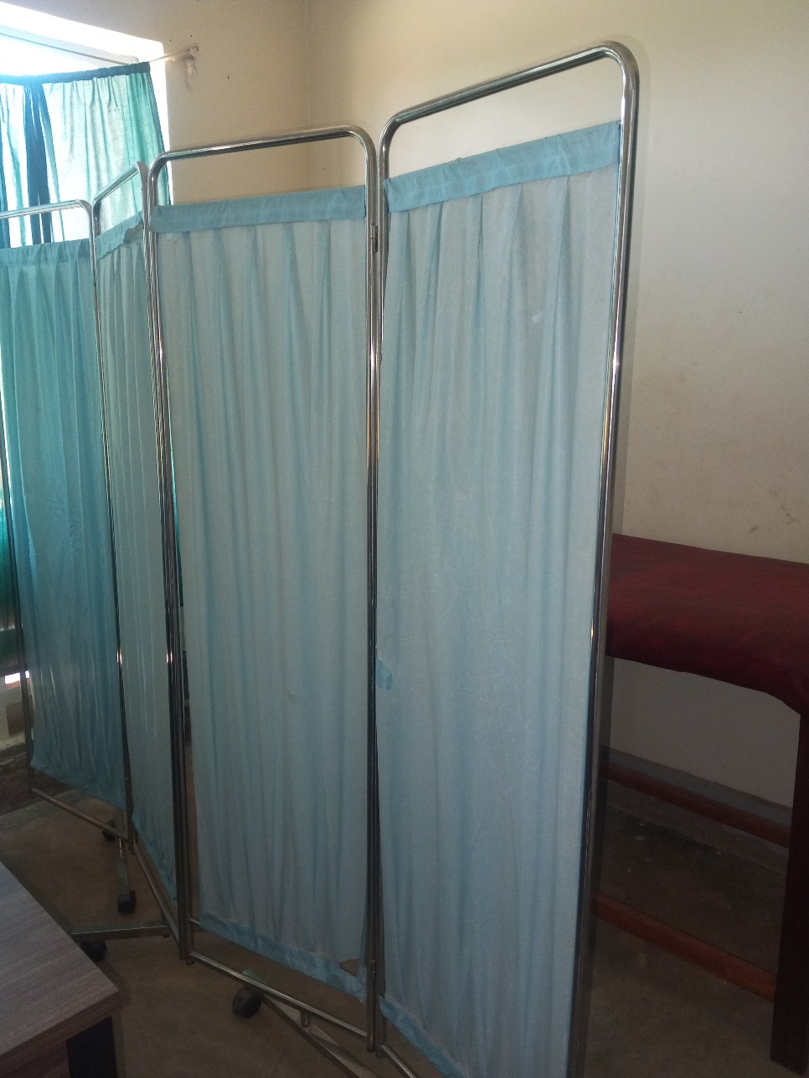

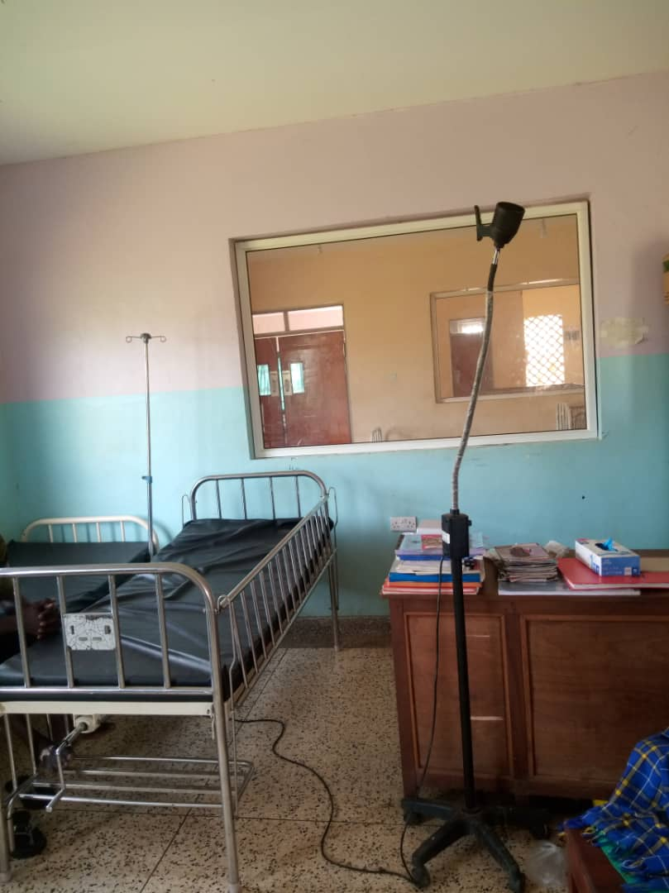

Patient Bed with
Examination Light LED

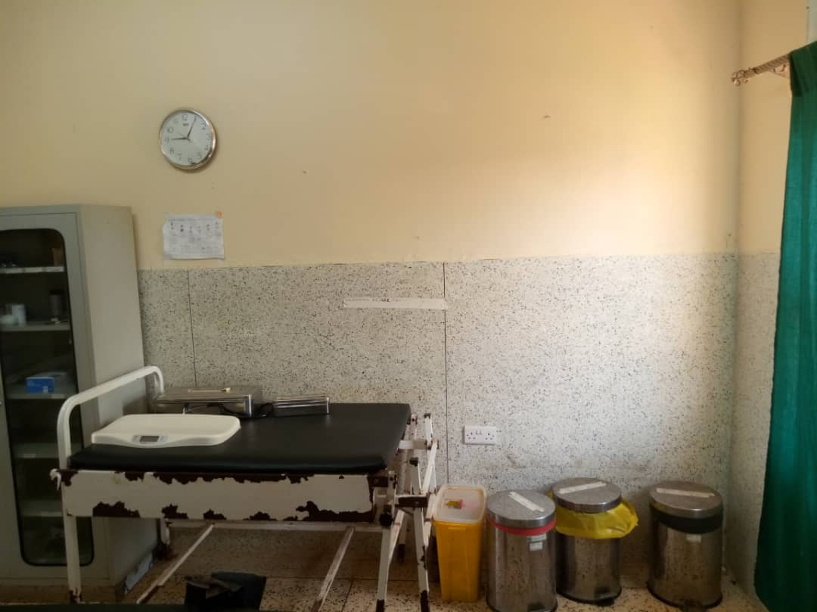

Examination Couch,
Wall Clock
and
Weighing Scale Infant

SCHOOL VERIFICATION CHECKLIST

SCHOOL INTERVIEW/DISCUSSION GUIDE

Name of school: ………………………………………………………………………………..

1a | Does the Facility have a record of all assets provided under UgIFT.  (Obtain a record and verify if it has the costs and numbers supplied
1b | If Not ask how many were supplied and when.

2 | How does this facility Maintain (repair/service/replace) the assets provided under Ugift

3 | Does the facility take regular record about functionality/ or breakdown of the assets provided?  Nonfunctional/ working, and reasons for non-functionality.

4 | How has the UgIFT support helped in service delivery in the area, any issues, challenges and any recommendations for better program implementation.

PROCEED TO VERIFICATION AFTER THIS DISCUSSION

SCHOOL FURNITURE
(School Desks, Office chairs, Laboratory stools, Book shelves)

Name of LG………………………………………………………………… Name of SCHOOL………………………………………………………………………………

Equipment/ Item | Department | Asset Number | Item  Description | Life in Months | Tag Number ( engrave no.) | Date Of Pur | Date Placed In Service | Recoverable cost | Cost | Acc Dep Cost | Net Book Value | Ytd Deprn | Equipment status | Remarks

ICT ITEMS TO VERIFY
(Desktop Computer, Server Processor, Network Switch 24 Port, Multipurpose Printer, UPS, Projector, Air Conditioners, Server, CCTV Camera)

Name of LG…………………………………………………………………………… Name of SCHOOL………………………….………………………………………

Equipment/ Item | Department | Asset Number | Item  Description | Life in Months | Tag Number ( engrave no.) | Date Of Pur | Date Placed In Service | Recoverable cost | Cost | Acc Dep Cost | Net Book Value | Ytd Deprn | Equipment status | Remarks

BUILDINGS TO VERIFY
(Non- Residential and Residential, Kitchen, Toilets/Pit latrine Water tanks, Fences etc.)

Name of LG…………………………………………………………………………… Name of SCHOOL………………………….………………………………………

Equipment/ Item | Department | Asset Number | Item  Description | Life in Months | Tag Number ( engrave no.) | Date Of Pur | Date Placed In Service | Recoverable cost | Cost | Acc Dep Cost | Net Book Value | Ytd Deprn | Equipment status | Remarks

